CSO Lab 7 : Displaying with 8051
Question: Write a program that uses a push button to start and stop a 4-bit binary up counter.
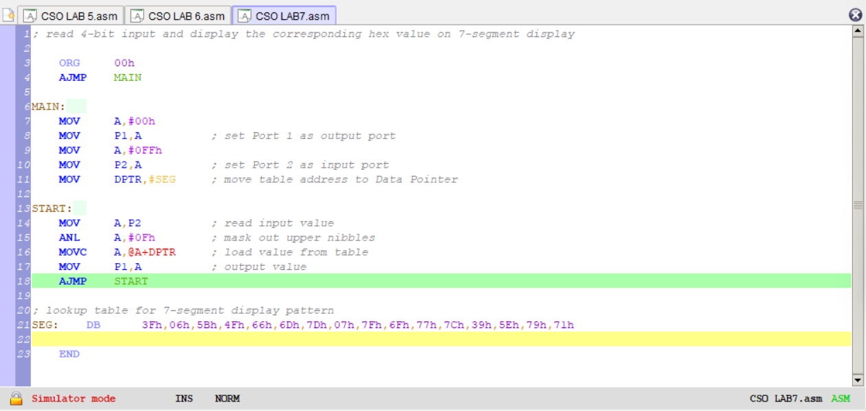

Component | State | Logic Level | Result
Switch | Open | 1 | Pin is High (VCC)
Switch | Closed | 0 | Pin is Low (GND)
7-Segment (CA) | Pin Low | 0 | Segment lights up (Path to GND)
7-Segment (CA) | Pin High | 1 | Segment is dark (No voltage difference)
Demo Video
https://drive.google.com/drive/folders/1rnfQfxfr03Xsfzd2DmIeLebdBVp3SIGy

